**12. Write a Java Message Service program to implement a simple client server application using publisher/subscriber messaging domain.**

**MYLISTENER.JAVA:**

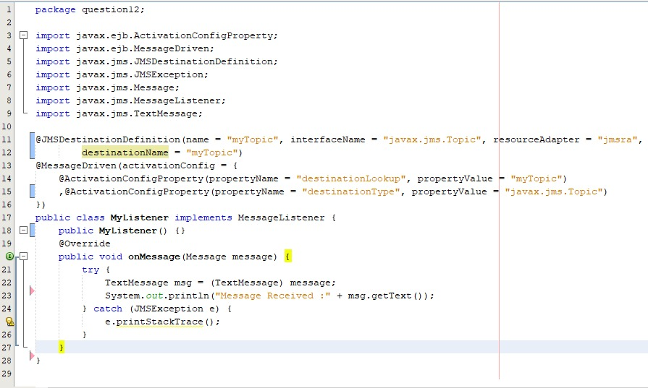

**MYSENDER.JAVA:**

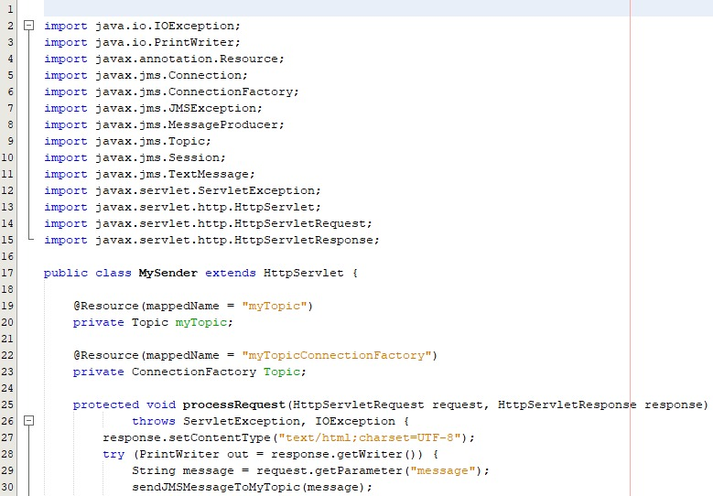

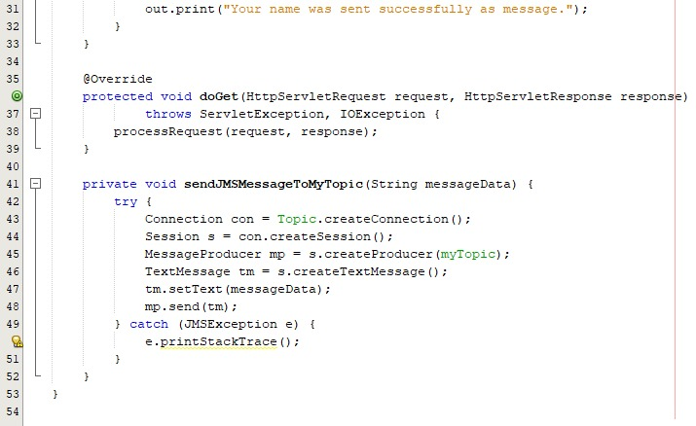

**INDEX.HTML:**

